Unit 12 Problem Set Submission Form

# Overview

|  |  |
| --- | --- |
| Your Name |  |
| Your SU Email |  |

# Instructions

Put your name and SU email at the top. Answer these questions all from the lab. When asked to include screenshots, please follow the screen shot guidelines from the first lab.

Remember as you complete the problem sets it is not only about getting it right / correct. We will discuss the answers in class so it’s important to articulate anything you would like to contribute to the discussion in your answer:

* If you feel the question is vague, include any assumptions you've made.
* If you feel the answer requires interpretation or justification provide it.
* If you do not know the answer to the question, articulate what you tried and how you are stuck.

This how you receive credit for answering questions which might not be correct.

# Questions

Answer these questions using the problem set submission template. You will need to consult the logical model in the overview section for details. For any screenshots provided, please follow the guidelines for submitting a screenshot.

Write the following as SQL programs. For each, include the SQL as a screenshot with the output of the SQL Code.

1. Using the **payroll** database write an index to improve the performance of the following query. Your screenshot should include the created index SQL code and the query plan demonstrating the index is being used.
2. Write another query using GROUP BY which also uses the index you created in the first question.
3. For the following query from a previous assignment, which provides a rank of each bid on an item:  
   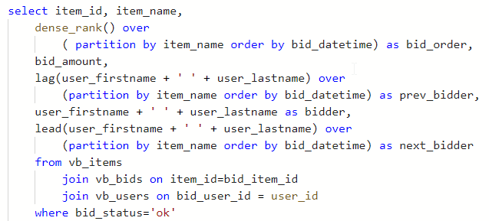  
   implement the query and run it. Provide a screenshot of the query plan and include the portion where the **vb_bids**, **vb_items,** and **vb_users** tables are selected and joined together.
4. Write an index to improve performance of the query by replacing the clustered index scan on **vb_bids**   
   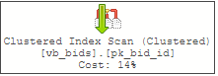  
   with an index seek on the same table. Provide a screenshot of your index code and a screenshot of the query plan demonstrating the index is being used to draw data into the query.
5. Using **fudgemart_v3**, create a schemabound view from the following query:   
   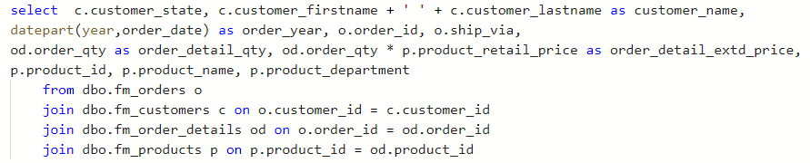  
   Name the view **v_orders** . Provide a screenshot of the code and sample output which conveys the query ran and created the view.
6. Write code to add a unique clustered index to the view **v_orders**. Execute your view ( **select * from v_orders)** and then observe the query plan to see if the index is being used. If the index is not being used, that’s an indication there is not enough data to warrant the index. You can force the index to be used by using the **noexpand** option on the query: **select * from v_orders with (noexpand)** Provide a screenshot of code to create the index and execute the view along with the query plan showing the index is used.
7. Write code to add a columnstore index to **v_orders** include all the columns from the view in the column store index. Provide screenshots with code to demonstrate you created the columnstore index and that these queries use it:  
   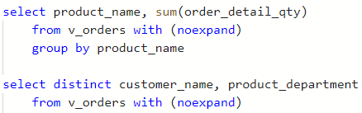

# Reflection

Use this section to reflect on your learning. To achieve the highest grade on the assignment you must be as descriptive and personal as possible with your reflection.

1. What are the key things you learned through the process of completing this assignment?
2. What were the challenges or roadblocks (if any) you encountered on the way to completing it?
3. Were you prepared for this assignment? What can you do to be better prepared?
4. Now that you have completed the assignment rate your comfort level with this week’s material. This should be an honest assessment: (choose one)  
     
   4 ==> I understand this material and can explain it to others.  
   3 ==> I understand this material.  
   2 ==> I somewhat understand the material but sometimes need guidance from others.  
   1 ==> I understand very little of this material and need extra help.